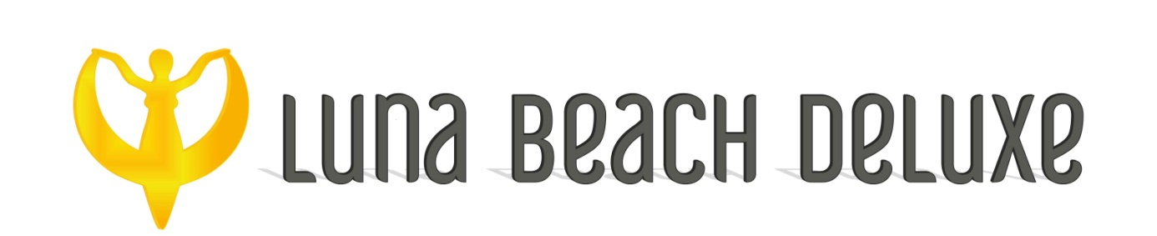
LUNA BEACH DELUXE 2022 SUMMER SEASON FACT SHEET

HOTEL NAME: LUNA BEACH DELUXE
CLASS : 5 *
BOARD : AI+
RENOVATION: 2015 WINTER SEASON
TOTAL LAND : 10.000 m2
ADRESS : BARBAROS CADDESİ TURBAN YOLU NO: 24 MARMARİS 48700
PHONE : +90 252 417 65 71
FAX : +90 252 417 65 30
E-MAIL : info@lunabeachdeluxe.com
WEB ADRESS : www.lunabeachdeluxe.com
VALID CARDS : MASTER,VISA
PETS : NOT ALLOWED
VOLTAGE : 220V
INTERNET : WI-FI IN GENERAL AREAS
TOTAL ROOM : 203

LOCATION: Hotel is located right on the beachfront of Marmaris. 100 mt to the main street. Every five minutes minibus is available to the centre. Hotel is surrounded by restaurants and shops. Marmaris center is 3 km to the Hotel. Dalaman airport is 90 km to the Hotel.

STANDART ROOMS : 116 ROOMS
1 Bedroom. Twin or double bed. Air Condition (Split). Direct telephone , Satelite Tv , Hair dryer, minibar , safe box . Max. 2 adults + 1 child or 3 adults.

FAMILY ROOMS : 87 ROOMS
1 Bedroom + 1 living room. Twin or double bed in the bedroom , 1 single + 1 sofa bed in living room. 1 bathroom. Air Condition (Split). Direct telephone , Satelite Tv , Hair dryer, minibar , safe box . Max. 2 adults + 2 child or 3 adults + 1 child.

ROOM CLEANING: EVERYDAY
TOWEL CHANGE : EVERY 3rd DAY
LINEN CHANGE : EVERY 3rd DAY
MINIBAR : FILLED ON ARRIVAL WITH JUICES and WATER
SAFE BOX : EXTRA (in the room)

FOOD & BEVERAGES

MAIN RESTAURANT:
BREAKFAST : ( 07:00 – 09:30 )
LATE BREAKFAST : (09:30 – 10:00 )
LUNCH : (12:30 – 14:00 )
DINNER : (19:00 – 21:00 ) Dress Code applied

SNACK RESTAURANT : ( 15:00 – 16:00 )
PATISSERIE : (10:00 – 22:00 ) - (17:00 – 18:00 ) CAFE BREAK.
ALA CARTE RESTAURANT: one time free (By the reservation)

BARS
LOBBY BAR : ( Open 24 hours) Hot drinks , soft drinks, non carbonated soft drinks
POOL BAR : (10:00 – 22:00 ) Local alcoholic drinks , some import drinks , soft drinks , non carbonated soft drinks.
BEACH BAR : ( 10:00 – 24:00) Local alcoholic drinks , some import drinks , soft drinks , non carbonated soft drinks.
PATISSERIE : (10:00 – 22:00) Hot drinks , Non carbonated soft drinks
(24:00 – 02:00) All drinks are extra.
POOL & BEACH
POOLS
- 1 main pool
- 1 Aqua pool
- 2 waterslides in Aqua pool
- 1 childrens pool
- Sunlounger and parasols by the pool
BEACH
- Sunlounger and parasols by the beach
- Pool & beach towels

FACILITIES
ENTERTAINMENT
- SOFT ENTERTAINMENT
- NIGHT SHOWS 6 DAYS IN A WEEK
- DAY TIME ACTIVITIES
- POOL ACTIVITIES
- BILLARD
- DART
- TABLE TENNIS
SPA & WELLNESS
- TURKISH BATH - FREE ENTRANCE WITH RESERVATION BETWEEN 14:00 – 16:00
- SAUNA - FREE ENTRANCE WITH RESERVATION BETWEEN 14:00 – 16:00
- ALL TREATMENTS ARE SUBJECTED TO A FEE
- GYM - FITNESS EQUIPMENTS FREE USAGE BETWEEN 09:00 – 18:00

EXTRA SERVICES
- DOCTOR ( ON CALL )
- OUTLINE PHONE CALLS
- LATE C/OUT
- ALL BOTTLED DRINKS INCLUDING BOTTLED WATER, FRESH JUICES. SOME IMPORT DRINKS. ALL DRINKS AFTER 24:00
- LAUNDRY SERVICES
- SPA TREATMENTS, MARKET
- SAFE BOX

**HOTEL HAS THE RIGHT TO CHANGE ALL FACILITIES TIMES AND PLACES.

