

**Poseidon Hotel Marmaris - Summer 2022**

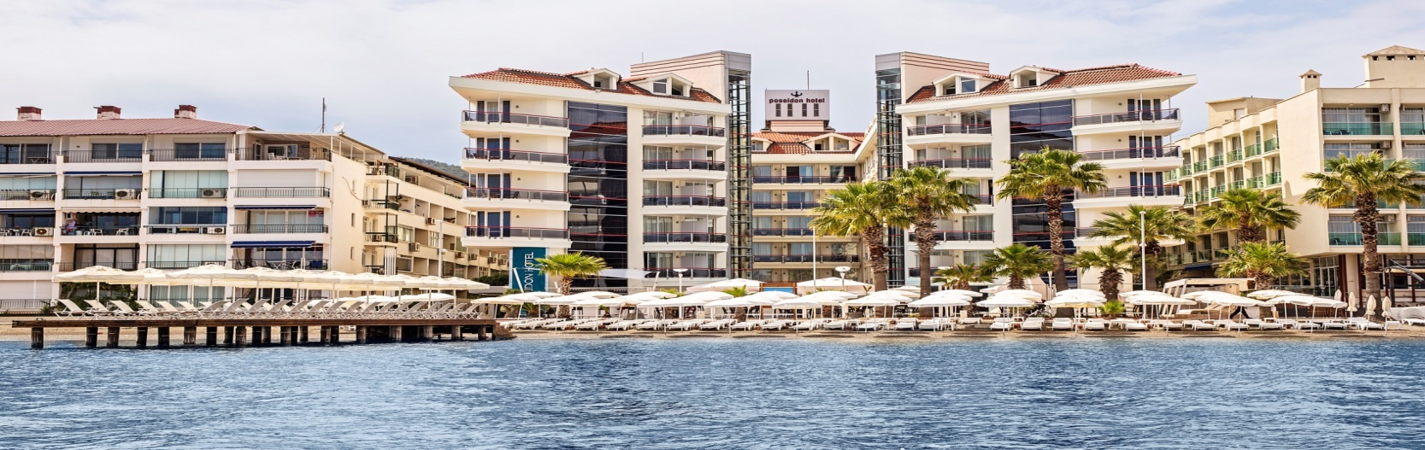

HOTEL NAME : POSEIDON HOTEL

CATEGORY : 4 Stars

ADDRESS : Uzunyalı Cad. 207 Sk.

No:116 Marmaris/Mugla

PHONE NUMBER : 0252 4177880 pbx

FAX NUMBER : 0252 4177906

Web site : [www.poseidonhotel.com](http://www.poseidonhotel.com)

E-mail [info@poseidonhotel.com](mailto:info@poseidonhotel.com)

[reservation@poseidonhotel.com](mailto:reservation@poseidonhotel.com)

Nearest airports : Dalaman 90 km.

: Milas 120 km.

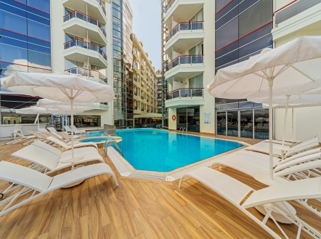

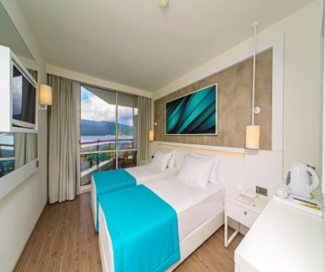

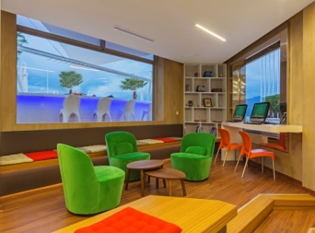



**ROOMS**

* **232 rooms**
* **Economy Rooms** : 16 sqm and located on 6th floor, max 3 people (sofabed), walk-in shower
* **Landview Rooms**: 16 sqm, mountain/land view, max 2 people), walk-in shower
* **Side sea view Rooms**: 17 sqm, located inner and exterior sides of the hotel, max 3 people (sofabed), walk-in shower
* **Seaview Rooms:** 17 sqm,located at the center of the hotel, max 2 people, walk-in shower
* **Frontal Seaview Rooms:** 17 sqm, located front side of the hotel, max 2 people, walk-in shower
* **Corner Suite :** 25sqm, located at the center of the hotel, max 2 people, walk-in shower
* Shower/WC, Minibar
* Direct Telephone, Safe Box(extra)
* Hair Dryer, Satellite TV (LCD)
* Some rooms are for 3rd person available, **(3rd bed is sofabed)**

**ACTIVITIES**

* Outdoor Swimming Pool
* Indoor Swimming Pool
* 2 Outdoor Jacuzzi
* Relax Pool (Outdoor)
* Blue Flagged Beach
* Turkish Bath/Steam Bath
* Fitness Center
* Massage (extra)
* Table Tennis(free of charge)
* Billiard (extra)
* Table Football (extra)
* Morning gymnastic and yoga
* Beach Volleyball
* Live music twice a week
* Soft animation

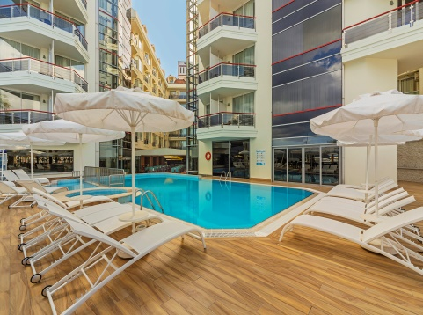

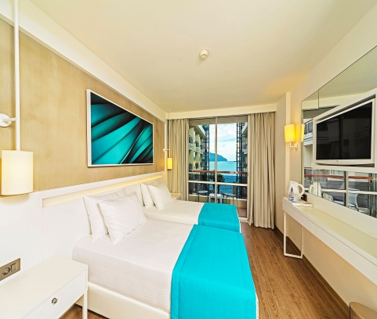

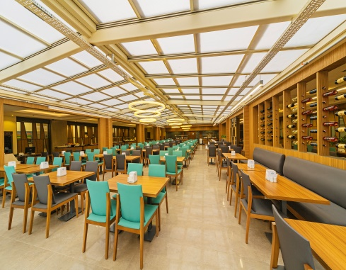



**GENERAL INFORMATION**

* Free Wi-fi (In Rooms and Public Areas)
* Laundry and Dry Cleaning (extra)
* Adults Only Hotel (16 years and older)
* Private Beach and Private Pier
* CCTV
* All Inclusive Concept (10:00 / 23:00)

**RESTAURANT AND BARS**

* POSEIDON RESTAURANT
* Breakfast 07:00 – 10:00
* Late Breakfast 10:00 – 10:30 (limited)
* Lunch 12:30 – 14:00
* Dinner 19:00 – 21:00
* Snack Time 12:00 – 15:00
* Fruit Time 15:00 – 16:00
* Tea/Cake Time 16:00 – 17:00
* Late Night Soup 23:00 – 23:30
* A’LA CARTE RESTAURANT
* Fish A’la Carte (per person 10.-Euro)

Watch the Moonlight at the restaurant, and then admire the sea views and sound of the waves while savoring exclusive flavors from Aegean cuisine and delicious seafood between 19:00–21:00.

* *Reservation is required*
* *Closed on Monday*
* Theme Turkish night buffett 1 time in a week
* POSEIDON RESTAURANT BAR(during meal times)
* MAIN POOL BAR
* Opening and closing hours of our all restaurants, bars and areas may be changed by hotel Management without priorly notifying

